ASSESSMENT 1: Web Programming
Assignment Title | Assessment 1 Set Exercises
Tutor | Ms. Lavanya Mohan
Date of Submission | March 29, 2026

Assessment 1: Web Programming
Students Name | Dexter May T. Hingada
Roll No | 0425117
Assignment Brief | This assignment features a compilation of completed exercises - submitted as requirements for the course: Web Programming under the department of Creative Computing for the First Term of the Second Semester in Level Four (1st Year). These exercises assess the acquired knowledge & practice of the student for the following languages: HTML, CSS, and JavaScript.
Github Repository Name | -CCL4-WPR-Web-Programming_Assessment-1-Set-Exercises
Github Repository Link | https://github.com/maehii/-CCL4-WPR-Web-Programming_Assessment-1-Set-Exercises.git
Repository Screen Shot | 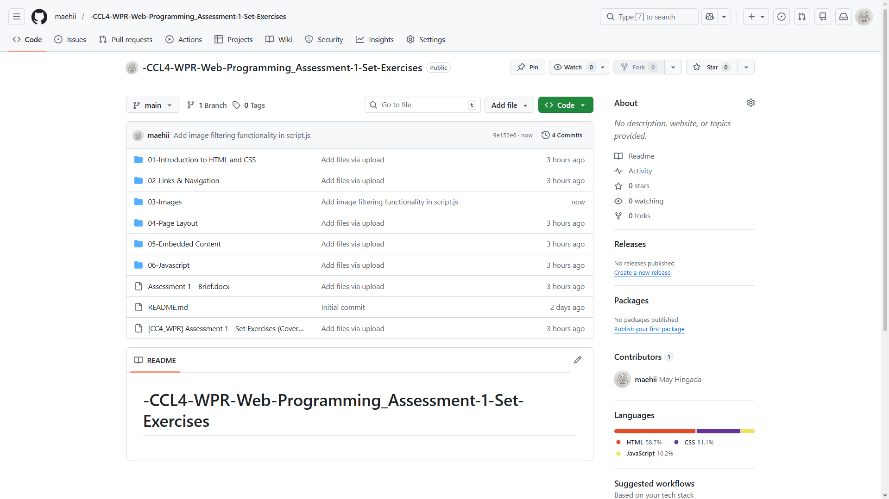
Other comments | n/a

